**Council of Three Rivers American Indian Center Early Childhood Education Programs**

***“Research continues to reinforce that what children learn before kindergarten affects their learning and success for life. The early years before kindergarten are unique; they lay the foundation for all future learning and social development and cannot be duplicated later in life. When it comes to early learning, there are no “do overs."***.

COTRAIC’s ECE programs provide preschool children with a comprehensive, flexible program designed to reinforce and respond to the unique strengths and needs of each individual child and family. Through the various models, Head Start supports a greater degree of school readiness skills and social competence in preschool children. To achieve this goal we utilize a nationally recognized/ research-based curriculum, which promotes self-confidence, academic awareness, social interactions, and wellness.

**Pennsylvania’s Pre-K Counts Program** was created to provide research-based, high quality pre-kindergarten opportunities to at-risk children across the commonwealth. Utilizing the successful Head Start model as a basis this program leverages existing early childhood education services in schools, child care programs, Head Start, and licensed nursery schools. Pre-K Counts is administrated by the state of Pennsylvania’s Office of Child Development and Early Learning (OCEDEL) and provides services for preschool children that are up to 200% of the federal poverty guidelines. The slightly higher income eligibility of Pre-K Counts allows COTRAIC to provide services to the children of many “working poor” families that are not income eligible for Head Start.

**Head Start** is a federally funded preschool program that serves low income at risk preschool children and their families, living at or below the federal poverty level. As such, these children are already considered “at risk” of entering kindergarten significantly less well prepared to learn and be successful in school. To address this issue, Head Start provides services which work together to increase school readiness and improve the quality of life for income eligible children and their families. Services include education, nutrition, health and wellness, opportunities for family engagement and support services for families as well as services for children with special needs, transportation and more.;

**Parents and Families**

In addition to providing a quality early childhood education experience for preschool-aged children, COTRAIC ECE also offers individualized support services for families. In administering each of its early childhood education programs, COTRAIC understands a healthy functional family and support system is a child’s biggest asset in achieving school readiness. We take a holistic approach to school readiness by including services designed to improve the quality of life for the children and their families. Parent, family and caretaker development, specifically, increasing self sufficiency through the introduction of effective life management skills is an integral part of our program. COTRAIC ECE offers parents opportunities and support as they identify and meet their individual goals, as well as nurture their children in the context of their family and culture. In order to ensure the best possible outcome, parents are educated, information is shared, direct services are provided and referrals are made to other community providers.

**Focus on Quality**

COTRAIC’s ECE centers have been accredited by the National Association for the Education of Young Children (NAEYC) for over 15 years. Our professionally trained, degreed education staff, provides individualized, comprehensive learning experiences for children in a culturally sensitive environment. Education Services are designed to promotes school readiness, increase academic awareness and enhance social skills and interaction.. Statistics provided by the Pennsylvania Office of Child Development and Early Learning (OCDEL), indicate that less than one in five preschoolers begin the school year in state Head Start programs with age appropriate skills. Each year COTRAIC documents and analysis the education outcomes for all enrolled children; at the end of the last program year, 96% of children who attended COTRAIC’s early childhood classrooms were proficient in language and literacy, 97% in mathematical thinking, 98% in personal and social development and 96% in scientific thinking. This progress in growth and development translates into children who will enter school ready to learn and be far more likely to achieve lifelong academic success. Other program services are provided to support and enhance our education outcomes. These include but are not limited to: Health and nutrition - Staff, emphasize the importance of early identification of health problems by providing a comprehensive health care program and regular assessments. We work with our families to ensure children are current with their annual preventative well-child examinations, dental examinations, immunizations and screenings. Families are encouraged to make and keep appointments, and complete all necessary follow-up and staff is on hand to assist families in identifying local doctors and dentists who can provide necessary service and assist families in accessing those services. Staff, in partnership with parents, develops an individual health plan for each child designed to address their unique needs. Our nutrition staff prepares healthy well balanced meals and snacks, which are provided to all children at no cost to the family. Children receive a minimum of one meal and one snack each day, free of charge. COTRAIC’s social service staff recruits and enrolls eligible children and families, provide outreach and support services as well as information and referral for services available outside our program. We encourage parent participation and assist families in securing basic family needs. Supportive services are available for children with special educational, behavioral or physical needs, including Early Intervention services. Although the majority of our participants come from low income families, up to 10% of our enrollment can be children from families above the poverty level who have special needs or other circumstances that place them at risk for academic failure

**Transportation**

**COTRAIC is the only Head Start program in Allegheny County that provides transportation.** Transportation is provided on a first come, first serve basis and is available at all COTRAIC operated centers EXCEPT Loreto. Transportation routes vary from year to year and bus stops are established based on the geographical location of the majority of program participants enrolled at the beginning of each school year..

## Eligibility

We encourage any family interested in enrolling their child in one of COTRAIC’s ECE centers to call and speak with one of the intake staff to discuss their specific circumstances and determine eligibility. However, we have provided some basic eligibility information below as a starting point. If you meet the criteria listed below your child is categorically eligible for services.

If your child is three or four or not eligible for Kindergarten and you fall within the federal income guidelines which determine eligibility for Head Start or Pre-K Counts.

If you are currently receiving TANF cash, SSI, are homeless or a foster parent of a preschooler

## How Do I Start The Process?

Call any of our centers

What Do I Need to Complete the Application Process?

* Birth Certificate (or other proof of birth)
* Verification of income (tax documents, pay stub, or documentation of SSI, TANF or unemployment)
* Immunization records
* Disability documentation  (if applicable)
* Custody or court documents (if applicable)
* Health insurance card (if available)

**COTRAIC staff is available to assist all families in gathering documents, filling out forms and completing the application process.**

**Locations of Pre-School Centers**

**Dorseyville Center (412) 782-4457** 4 classrooms located at120 Charles Street, Dorseyville, PA 15238

**Hazelwood Center (412) 421-6379** 3 classrooms located at:4900 Second Avenue, Pittsburgh, PA 15207

**Loreto Center (412) 531-3290** 5 classrooms located at:1901 Pioneer Ave., Pittsburgh, PA 15226

**Overbrook Center (412) 882-1481** 6 classrooms located at: 2413 St. Norbert’s Drive, Pittsburgh, PA 15234

**Rochelle Center (412) 488-2750** 10 classrooms located at201 Rochelle Street, Pittsburgh, PA 15210

**Child Care Partners**

**COTRAIC** contracts with several high quality childcare facilities to provide comprehensive services to Head Start and Pre-K children enrolled in full time childcare. Staff from COTRAIC ECE and the childcare work together to ensure children and families receive adequate support and a quality early childhood education experience. Our child care partners include:

**Crafton Children’s Corner** 412-563-2273 **(Infant, Toddler & Preschool)**

2760 Banksville Rd., Pittsburgh, PA 15216

**Mt. Washington Children’s Center** 412-381-1515 **(Infant, Toddler & Preschool)**

200 Southern Avenue, Pittsburgh, PA 15211

**Program Design**

* Half Day - Morning and afternoon sessions – four days a week. Limited availability (Rochelle St. Center only)
* Extended Day - 8:30 to 2:00 – five days a week

**Partnerships and Special Programs**

COTRAIC ECE programs participates in over 35 collaborations and partnerships with a wide variety of other local, regional and state organization, designed to create a tapestry of shared resources and improve the quality of services we provide for the families and children participating our programs. The following are a few highlighted initiatives made possible through those partnerships:

**PNC Grow Up Great** : COTRAIC has been proud to partner with PNC in its a $250 million early childhood education initiative known as *Grow Up Great,*  since its inception over 10 years ago. Funded by The PNC Financial Services Group, *PNC Grow Up Great* and *PNC Crezca con Éxito* form a comprehensive, bilingual program designed to help prepare children particularly underserved children from birth to age five for success in school and life. Through *Grow Up Great*, PNC provides the leadership, advocacy, funding, resources and volunteers to help parents, caregivers and communities in their efforts to increase the potential for young children to succeed. Our program operations have been enriched by the human and financial contributions of the PNC Grow Up Great program.

**PNC Building a Financial Future (BFF Project):** Family stability, including financial stability, is critical to a young child’s development. Research over the last twenty years shows that income alone is insufficient to achieve financial stability, and that building assets in addition to income produces an array of positive effects for families. The BFF is a pilot project designed to promote financial stability for low-income families with young children. A public-private-nonprofit partnership conceived as part of the Administration for Children Youth and Families ASSET Initiative in Region 3, the project embeds asset building activities and evaluation tools into Head Start programs over a two-year period. The initiative utilizes an educational model which provides training and workshops for parents, train the trainer opportunities for staff, as well as an age appropriate curriculum add on, which is used in each of the preschool classrooms.

**Eva Tansky Blum Science and Technology Lab:** In October of 2011 Eva Blum was recognized for her tireless efforts in building PNC’s Grow Up Great initiative from a concept for corporate philanthropy to a project that has improved the quality of education for over 250,000 preschool children since its inception in 2004. In true Miss Eva style, she requested that PNC’s recognition of her work be translated into science and technology resources for the children at the COTRAIC Head Start, the program she has faithfully volunteered at for the last ten years. Housed at our Overbrook facility, this resource center provides a variety of hands on state of the art science and technology resources and activity centers including a greenhouse, computer center and interactive Night Sky room. Each is designed to allow children to explore and learn through play. The Eva Tansky Blum Science and Technology Lab was dedicated in September 2012 and is open to all children in our program as well as children served through our community childcare partners.

## Tickets for Kids: COTRAIC partners with the Tickets for Kids program to provide opportunities for educational, cultural and recreational activities for low income children and their families. The tickets provided through Tickets for Kids are made available through the generous donations individuals, groups and businesses who contribute as a way of ensuring that children served by non-profit and social service agencies and community groups have access to various local events, attractions and performances. COTRAIC staff chaperone the children and make all logistical arrangements.

## Music, Movement and Culture: Made possible through the generous donations of several community partners, COTRAIC ECE has been able to introduce preschool children to a variety of the performing arts. Activities include the ballet and opera as well as several other music and creative movement experiences specifically designed in an age appropriate way to allow the children to learn experience and develop an appreciation for the arts.

## Program Activities

## Parent Involvement: Active parent participation is one of the cornerstones of Head Start and is an integral part of COTRAIC’s ECE programs over the past 30+ years. Engaging parents as active participants not only in the educational planning for their own children but in the program planning as well provides countless benefits for both the programs and the families. Parents can volunteer in their child’s classroom, on the bus, in the kitchen or offices as well as become a member of their center level parent committee or the Head Start policy council.

## Program Governance: Parents wishing to be involved in program governance are encouraged to become involved with our Policy Council. Parents are elected by peers to represent their center on Policy Council and receive training from the staff to ensure that they can carry out their roles and responsibilities. The Policy Council works with the program staff to make decisions regarding activities, program design, budgets, policies and procedures, hiring; as well as participates in the program self assessment and community needs assessment. The Policy Council meets with the program staff on a monthly basis and quarterly with our Board of Directors.

In addition to those mentioned above there are a number of other activities and initiatives available for parent participation.

**Fatherhood Meetings** – promotes active male involvement in the lives of young children.

**Home Activities** – extends learning beyond the classroom and engages parents in the process

**Job training** – provides hands on experience at the centers, for parents seeking to go into the fields of education, nutrition or social services. Assists and pays for the certification testing (Child Development Associate Certificate for education, Food Handlers Certificate FHC for nutrition, Family Development Certificate for social service) for parents who complete the OTJ portion of the program.

**Russell’s Readers** – promote in home and center level literacy efforts.

**“The more that you read, the more things you will know. The more that you learn the more places you'll go.”**Dr. Seuss

A project inspired by our Executive Director, Russell Simms, “Russell’s Readers” was developed to encourage children and families to read together. Families are asked to make a promise that they will read to their child each day. When the children tell their teacher about a book they’ve read at home, they get a hole punched in their Russell’s Reader card. When their card is filled, they get to choose a prize! The incentive gifts given to the children are graciously donated through a number of corporate sponsors including Kohls and

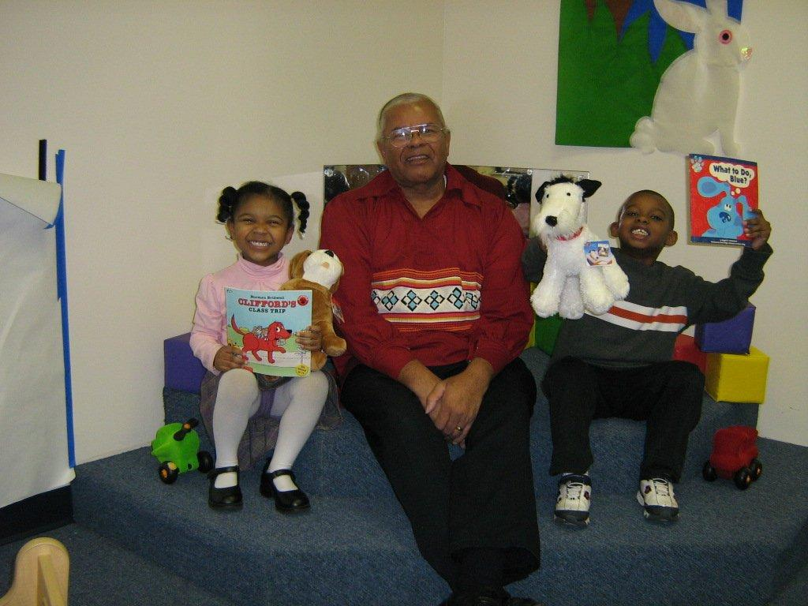

**Pictures if you need any – all have press and media release forms signed.**

